**AWS: How to create EC2 Instance**

1. Login to your Account
2. Select EC2
3. Enter/Type the name of your Instance (e.i: MyTestInstance)
4. Select the Application & OS Image (e.i: OS: Ubuntu, Windows, Red Hat, Amazon)
5. Select the Instance Type (i.e. : t1.micro, t2.micro, C5.large)
6. Key Pair(Login):
   1. If available than select that
   2. if not create new key pair
      1. Enter the name of key pair
      2. Select the key pair type (e.i. : RSA or ED25519)
      3. Select the Private key file format (e.i : .pem(For use with OpenSSH) or .ppk(for use with PuTTY))
7. Network Setting
   1. Create or select the Firewall(Security group)
8. Configure Storage
   1. Add New Volume
   2. File System
9. Advance Details
   1. Request for spot instance
   2. Domain join directory
   3. IMA Instance Profile setup

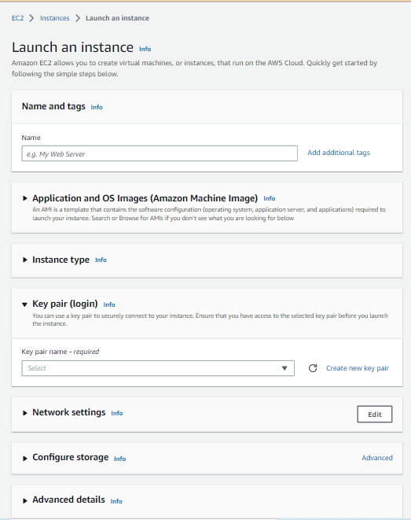

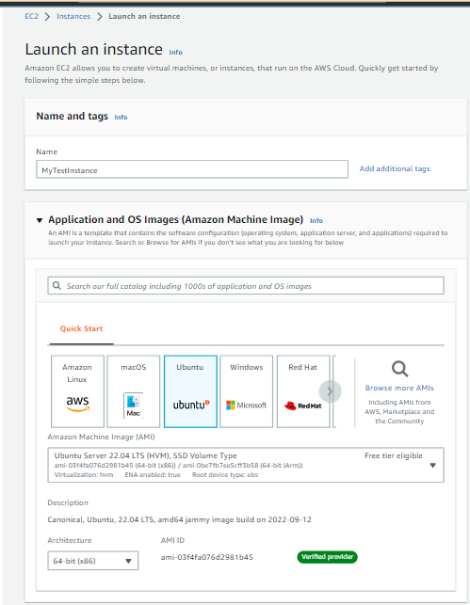

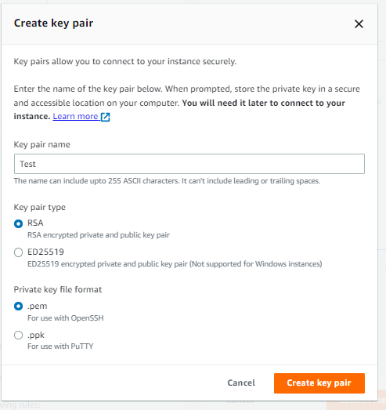

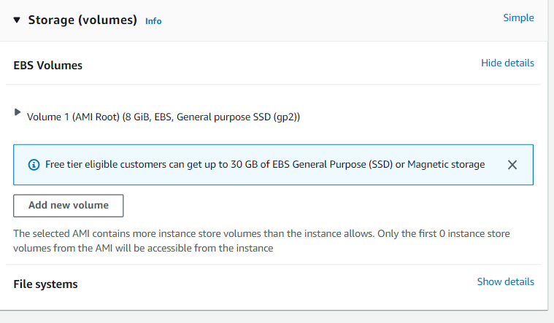

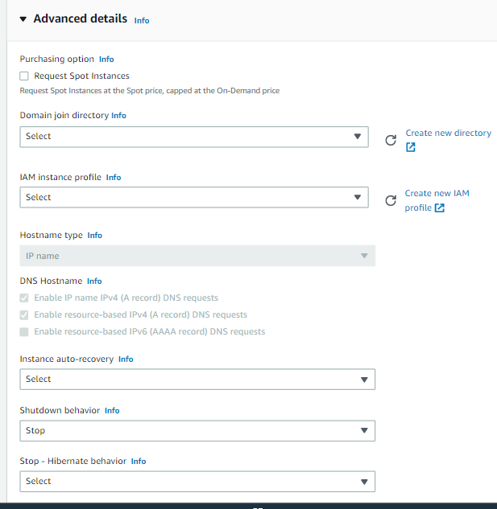

**How Login & get Access AWS instance from local system**

* + - 1. Download & Install PuTTY or mobaxterm
      2. Get **.PPK or .PEM file** from AWS Console
      3. Convert .PEM(not ppk) file into private file (OpenSSH Authorization Key file )by using the PuTTY Gen. Not required for macOS
         1. Open PUTTYGen(Automatically install with Putty)
         2. Load your .PEM file
         3. Save the private
      4. Get **Public IP**, **Instance ID** & Users name Details from AWS console
      5. Open PuTTY
      6. Enter your **ID/Host Detail**s with **port** number
      7. Click on **Connection => SSH => Auth =>** Browse your new generate file(**PPK** -> Putty Private key file on window machine) for MacOS(simple use .PEM file)

**How connect to an EC2 instance using SSH & Pem using Linux**

1. First check whether ssh client install or not in your local system

**Open Settings, then go to Apps > Apps & Features.** **Go to Optional Features.** **In the list, select OpenSSH Client or OpenSSH Server**

**Open Search => Manage Optional Feature => Check SSH Client & Server is install or not => if Not => Cliek on Add Icon => Search SSH and install both SSH Client and SSH Servre**

1. Go to pem file folder where you have keep it
2. Type the belo SSH command with this structure to connet your ec2 linux machine from your local system:

ssh -i file.pem username@ip-address=> Command Guide

**ssh -i "Test01.pem"** [**ubuntu@ec2-35-78-70-139.ap-northeast-1.compute.amazonaws.com**](mailto:ubuntu@ec2-35-78-70-139.ap-northeast-1.compute.amazonaws.com)

1. If if there is permission issue then type belo command(Run this command, if necessary, to ensure your key is not publicly viewable)

**chmod 400 Test01.pem**

**How to connect FTP/FileZila to an AWS EC2 instance using SSH & Pem using Linux**

1. Open FTP/FileZilla
2. Click on File => New Site Manager => Add New Site & Site Name
3. General =>
   1. Protocol => Select SFTP – SSH File Transfer Protocal
   2. Host Name: your public IP Address
   3. Logon Type=> Key File
   4. User => your user name like(ubuntu or ec-2)
   5. Key File => Your PPK File
4. Connect

**How to Run & Install package/software/OS/Dependency on Linux Server(OS image)**

1. **sudo apt update=>** sudo apt update is the command used to download and update the package information from all of the configured source
2. **apt list --upgradable =>** For get list of package/software for update
3. **sudo apt-get update** => for update apt package
4. **sudo apt upgrade** => For upgrade all packages with latest version
5. **apt install <packageName>** =>To install new package on linux server
6. **sudo apt install nginx** => For the installation of nginx on linux server
7. **sudo ufw app list** => Adjust the Firewall before testing the nginx
8. **sudo ufw status** => to check firewall is active or not
9. **sudo ufw enable** => to enable firewall
10. **sudo apt install maven -**y => For install the maven with (-y) agree consent
11. **cat /etc/os-release** => To check the install Linux / Ubuntu bersion
12. **nginx -v=> to check the install nginx version**
13. **java --version** => To check install java version
14. **mvn –version** => To check the install Maven version
15. **systemctl status nginx =>** to check the status of service like nginx

**How to Run & Install package/software/OS/Dependency on Amazon Linux(OS image) Server**

**1 yum -y update** => To update the system

2 **sudo dnf update -y** => To update the system

3 **sudo dnf install -y httpd php php-mysqli** mariadb105 => to install the httpd, php-mysql and mariandb105

5 **sudo systemctl enable httpd** => To enable / start the httpd service

5 **sudo systemctl start httpd** => To enable / start the httpd service

6 **sudo usermod -a -G apache ec2-user** => to add ec2-user as a global/super user

7 **clear** => To clear the terminal console

8 **history** => To get the history of terminal console

9 **df –h** => to get root valum storag edetaisl

10 l**sblk** => to get disk storage details

11 sudo systemctl httpd status => to check the service status of httpd

**How to Create AMIs(Amazon machine Image)**

1. **Select the EC2 Instance**
2. Click on **Action**
3. Click **Image & Template**
4. Click on **Create Image**
5. Type Your **Image-Name**
6. Click on **Create Image**

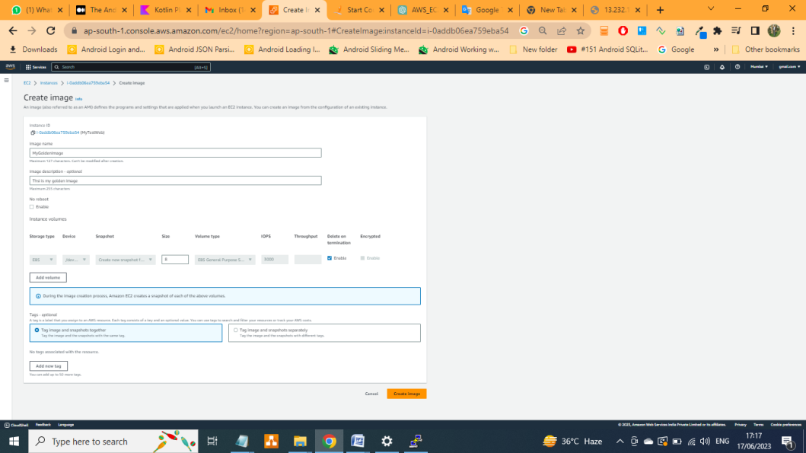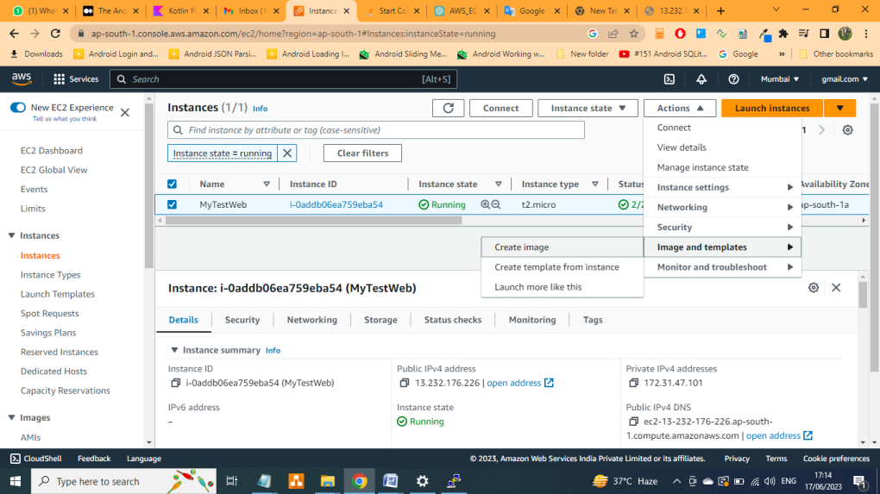

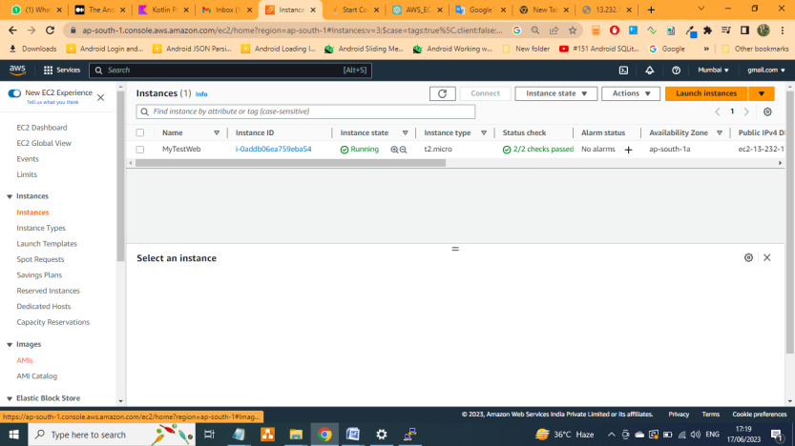

**How to Create EBS**

1. Go to EBS(Elastic Block Storage)
2. Select Valume
3. Creat eValume
4. Select Type of Valume(For free- Select Magnetic)
5. Size(GIB)
6. Avilabity Zone(will be same as EC2)
7. Create Valume

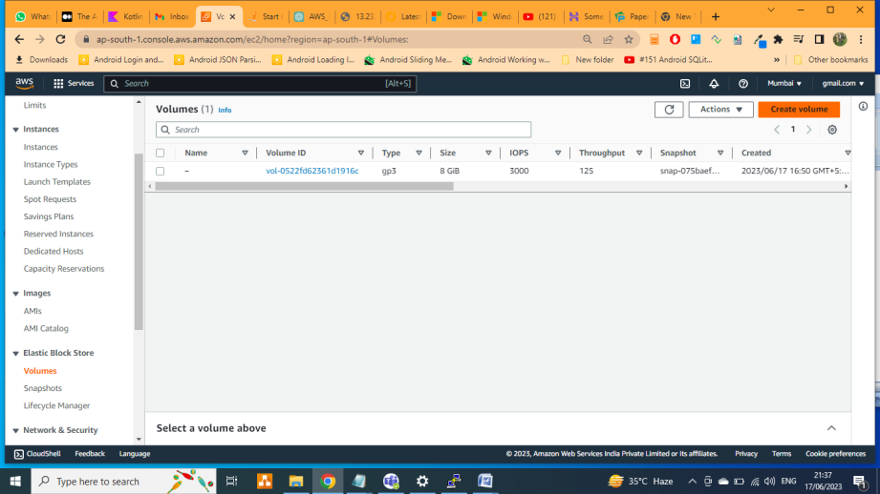

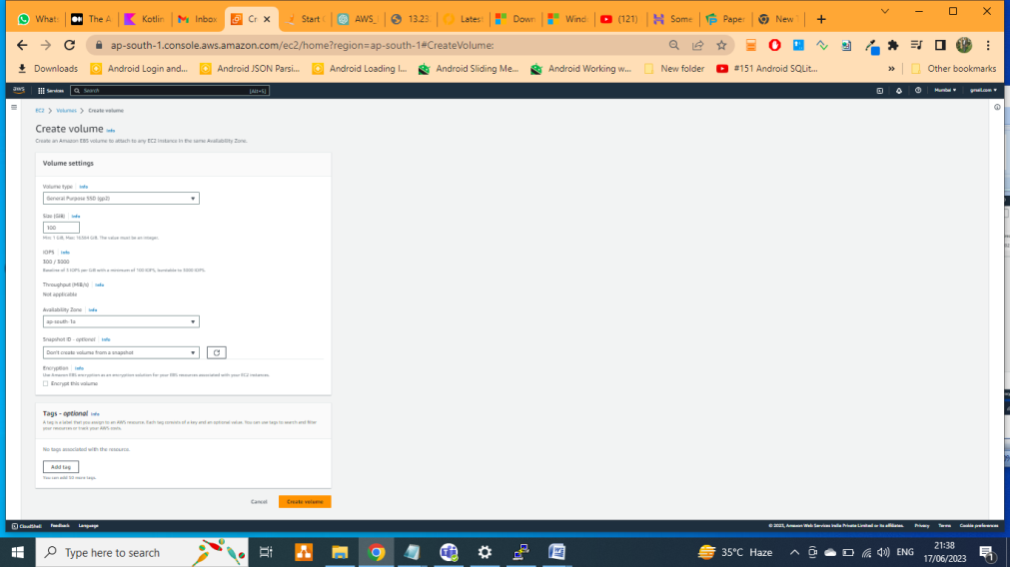

**How to Add/Attach EBS with running Instance**

* + - 1. Both **EC2 & EBS** must be in **same** **Zone**
      2. **Create an EBS** valume
      3. **Select The valume** which you want to attache
      4. Select **Action**
      5. Select **Attache Valume**
      6. Select the **EC2** **Instance**
      7. Click on **Attach**

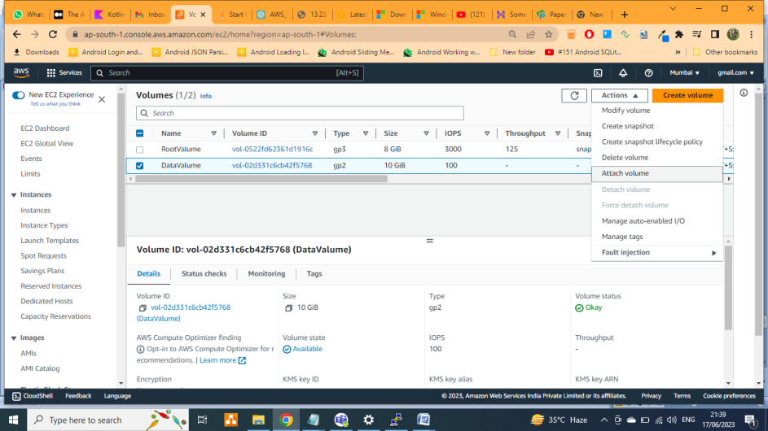

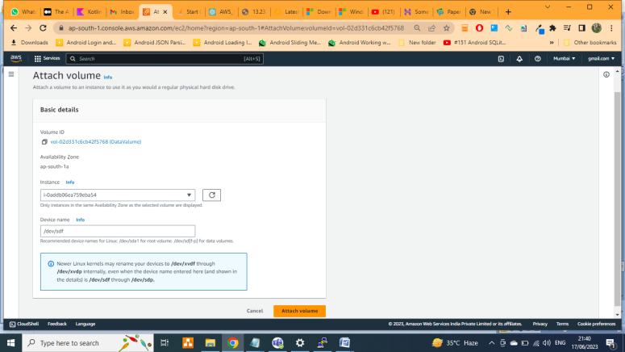

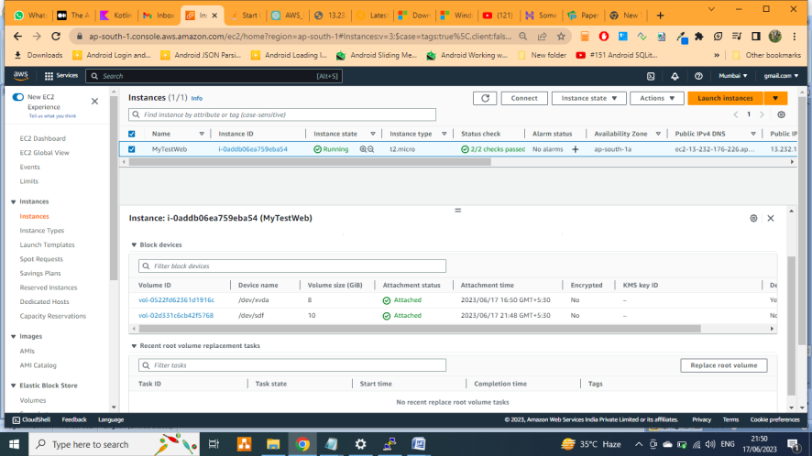

**How to create EBS snapshort/backup**

**Menual**

1. Go to EBS
2. **Valume**
3. **Select** the **Valume/EBS**
4. **Action**
5. Select the **Create the snapsho**t
6. Add your **discription**
7. Clikc on **Create snapshot**

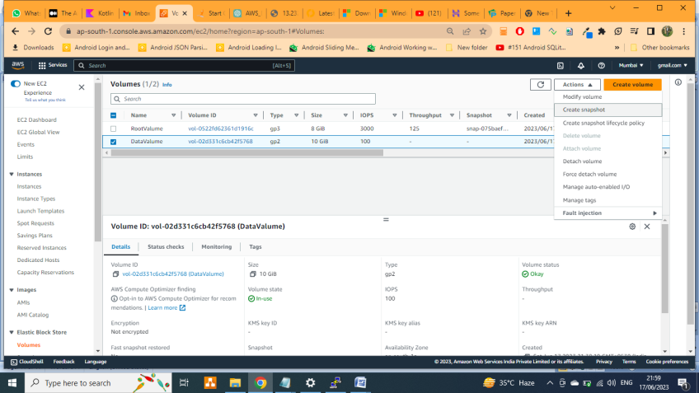

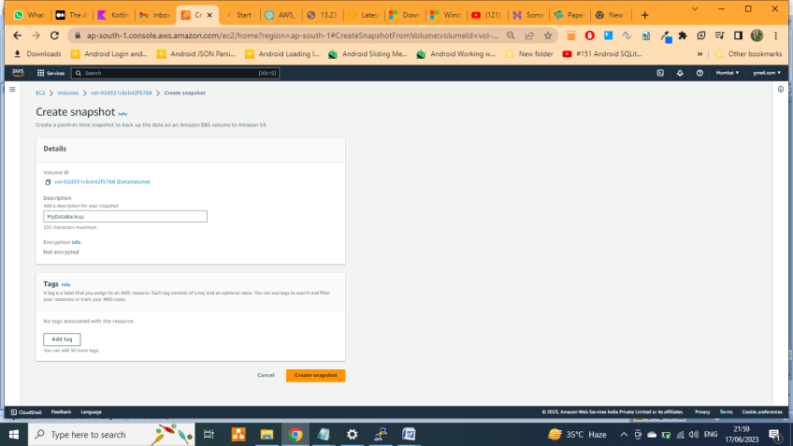

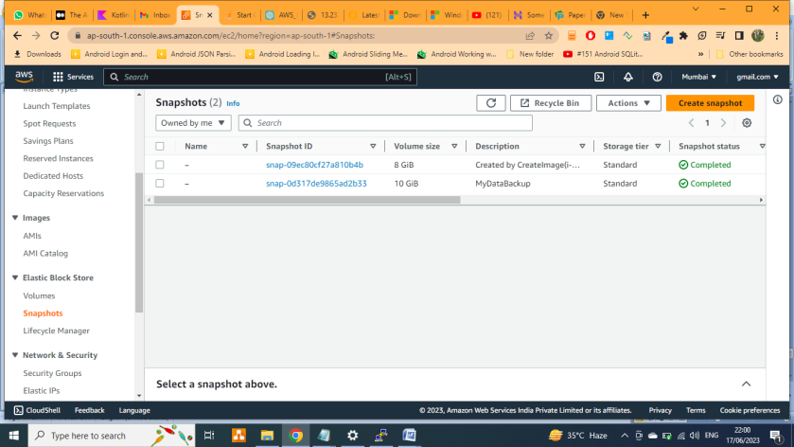

**Atomate/Scheduler**

1. Go to EBS
2. **Valume**
3. **Select** the **Valume/EBS**
4. **Action**
5. Select **create snapshot lifecycle policy**

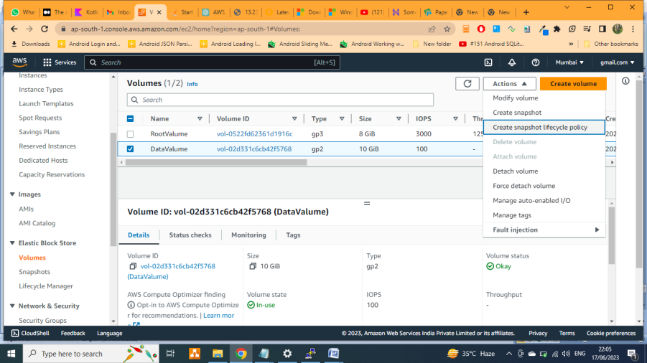

1. **Enter the details**

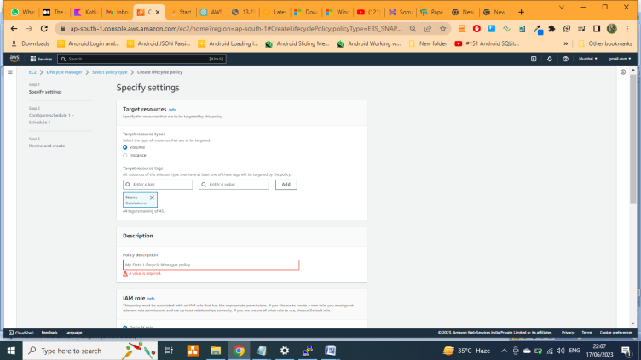

1. **Next**
2. **Provider your scheduler details(Date & time)**

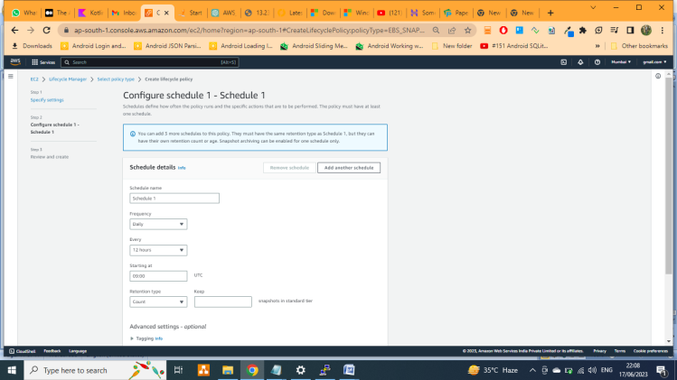

1. **Review & Create the Policy**

**How to EC2 Instance from our/saved AMIs**

1. **1st go and check your details of AMIs** 
   1. **Image => AMIs**
2. GO to **EC2 dashboard** and click on **create EC2 Instance**
3. Enter name
4. Tab on ‘’AMIs”
5. Select your image name
6. Create instance

**How to Attach single EBS value to EC2 Instance :** This is available with limited AMI

**Create & Manage IAM: (IAM -Identity and Access Management)**

1. Search & Go to IAM Dashboard
2. 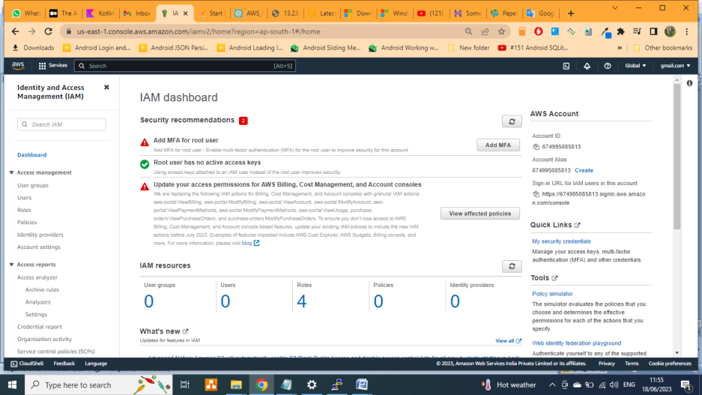
3. **User & Manage** 
   1. **Add Users**
   2. Enter your **user name**

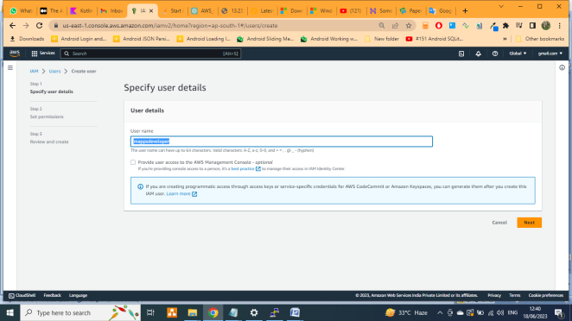

* 1. **Next**
  2. Select the **permission Options**
  3. Select your **Permission Policy**

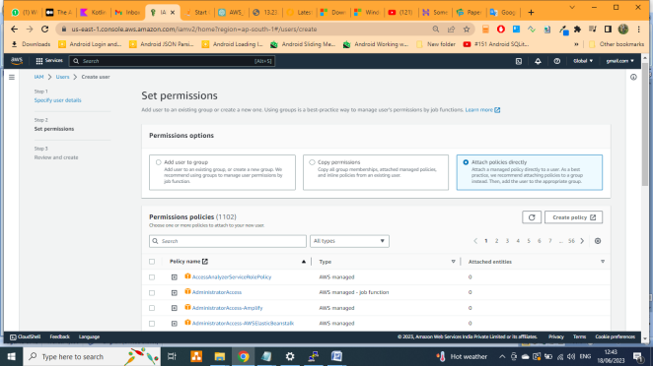

* 1. **Next**
  2. 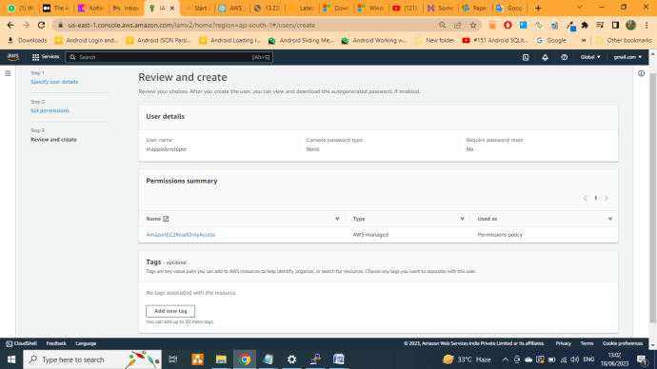
  3. **Create Policy**
  4. Select **the user(For Provide one time password)**
  5. **Securities Credentials => Console sign-in => Manage Console Access**

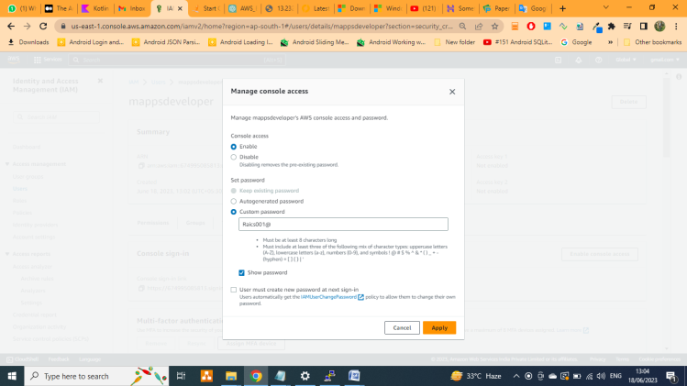

* 1. **Apply => Your credentials details**
  2. 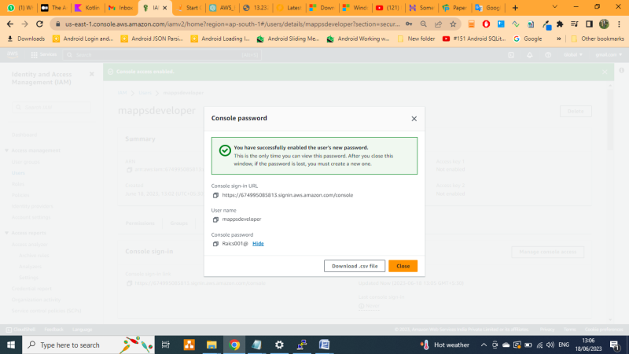

1. **Create & Manage UserGroup**
   1. **Click on Users Groups**
   2. **Create Users Group**

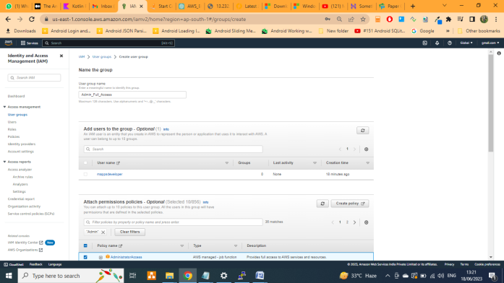

* 1. Enter your **Group Name**
  2. **Add users to the group – Optional** Or you can also add user after creating the group
     1. **Select the group**
     2. **Add user**
     3. **Select user**
     4. **Add**
  3. **Attach permissions policies – Optional**
  4. Click on **Create Group**

1. **Create Role**
   1. Click on **Role**
   2. **Create Role**
   3. Select your => **Trusted entity type** and => **Common use cases**

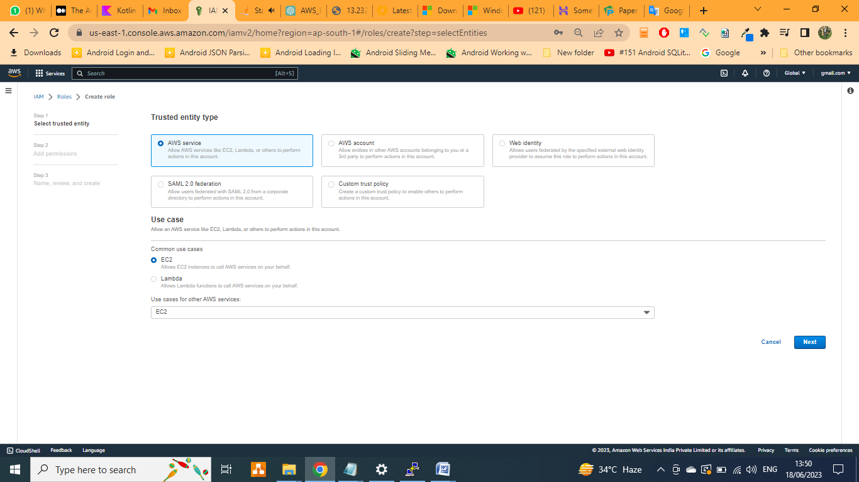

* 1. Next
  2. Select your **Permissions policies**
  3. **Specify the policy**

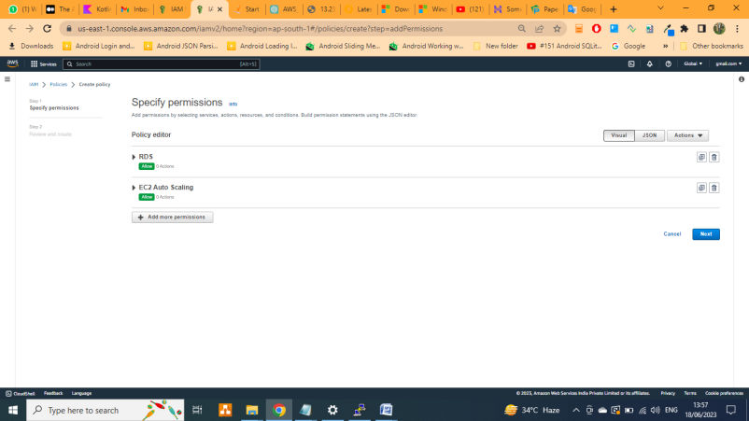



1. **Create & Manage Policy**
2. **Enable & Disable MFA(Multi factor Authentication)**

**Workshop: 1 / Practice - 1: Case study -1 | 20/06/2023**

**Problem Statement:** You work for XYZ Corporation. Your corporation wants to lunch a new web-based application using AWS Virtual Machine. Configure the resources accordingly for the tasks.

Task To be Performed

1. Create an Instance in the US-East-1(N. Virgina) regin with with an Ubuntu OS and install Nginx for making them web servers.
2. Change the default website with a page displaying the message: Hello Word”

**Lab: Practice**

1. Go To EC2 Dashboard
2. Create EC2 Instance
   1. Enter your “**Nmae & Tag**”
   2. Select the application OS : “**Ubuntu”**

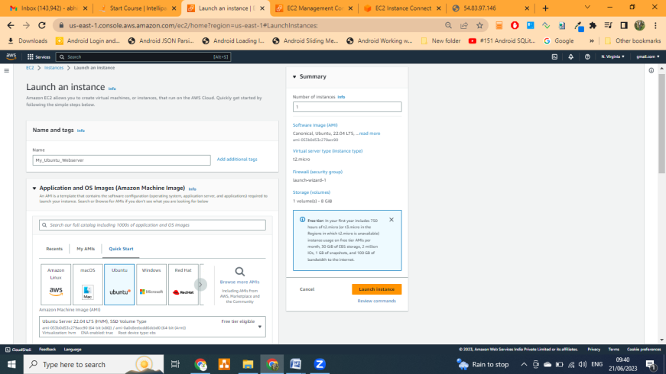

* 1. Create or Select the “**Key Pair**”

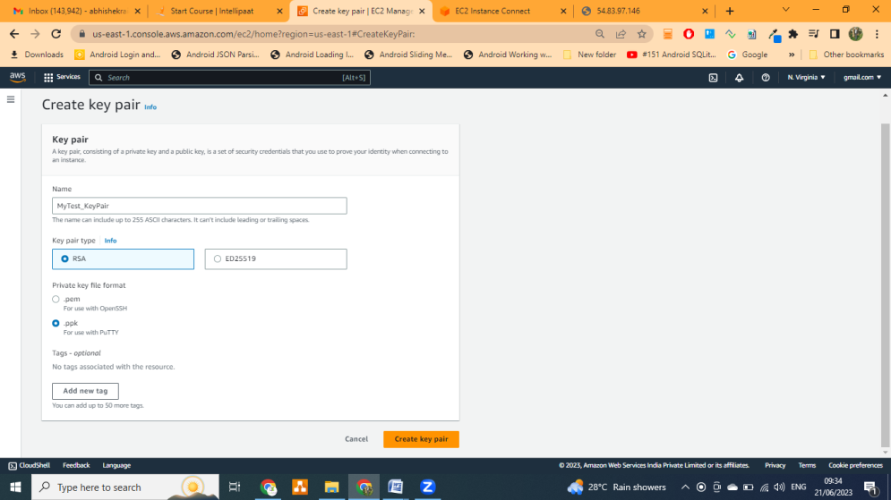

* 1. Create or Select the “**Security Group**” and make sure you enable the All Trafic/HTTP “**Sourc & Port**” with “**0.0.0.0/0**”

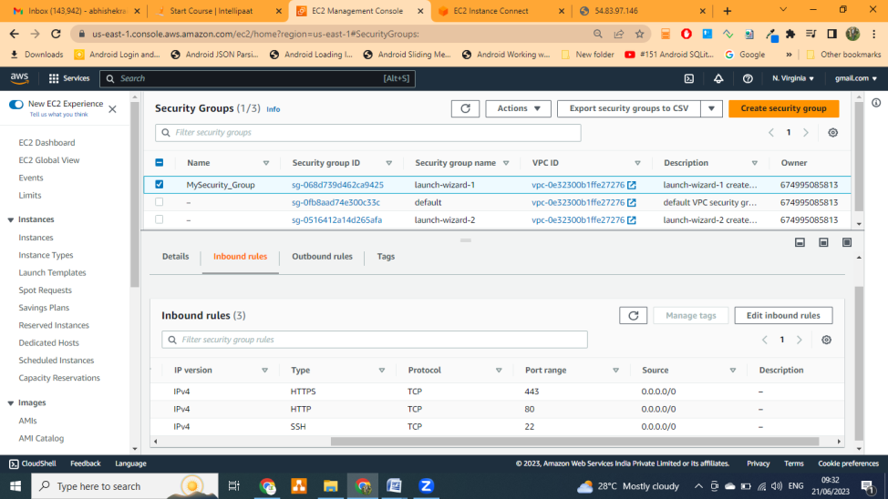

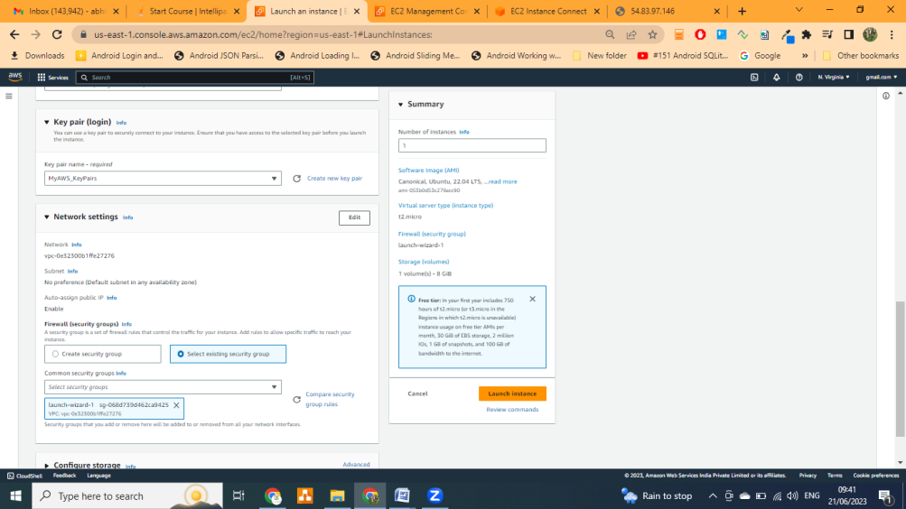

* 1. Lunch trhe instance
  2. Instance Details Like below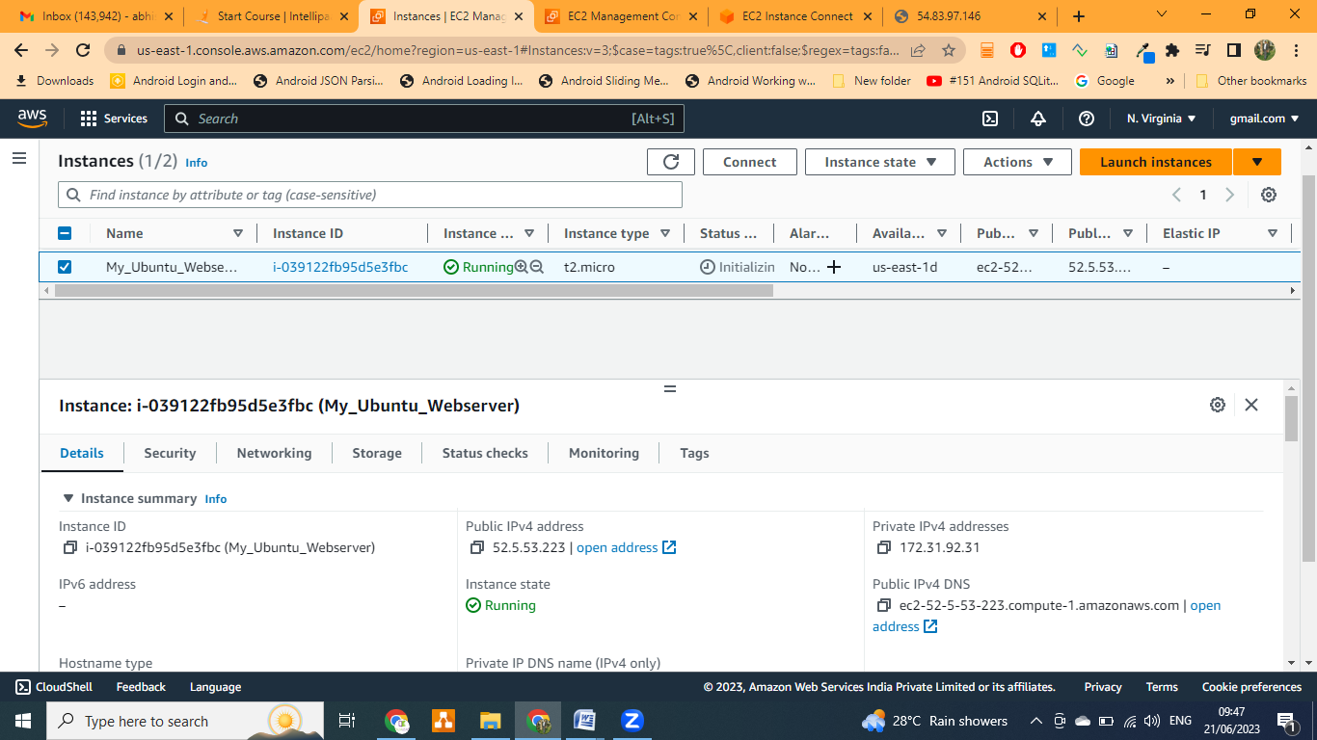

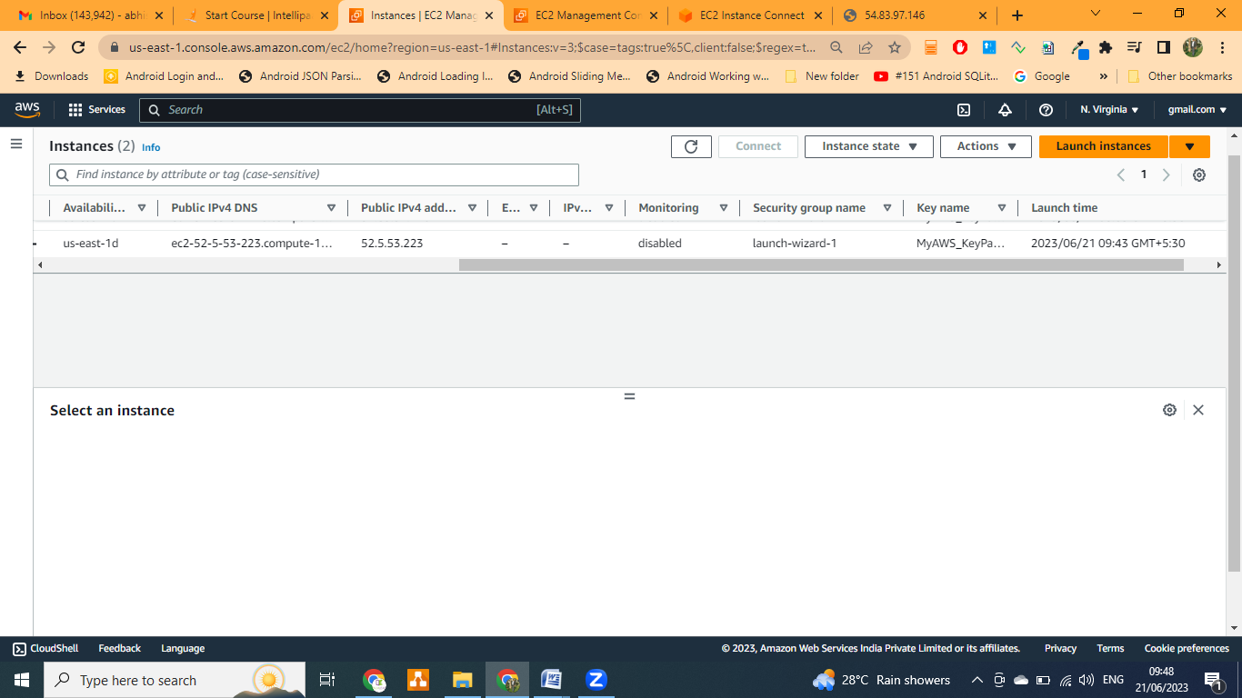

* 1. Connect you EC2 Instance though Putty or aws CLI and run the below command
     1. sudp apt update –y
     2. sudo apt install nginx –y

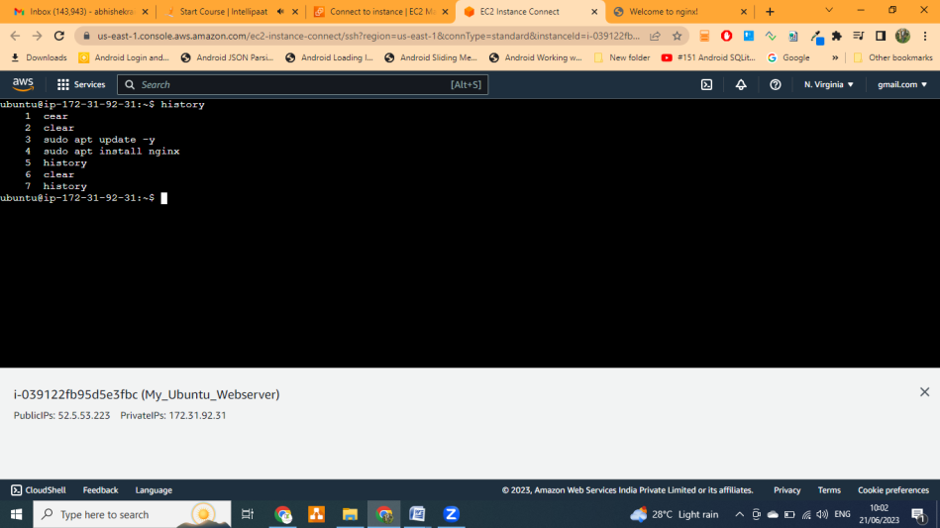

* 1. Now time to open your or type your public IP in url and check. Surprises 😊 you will able to see welcome Msg on on page

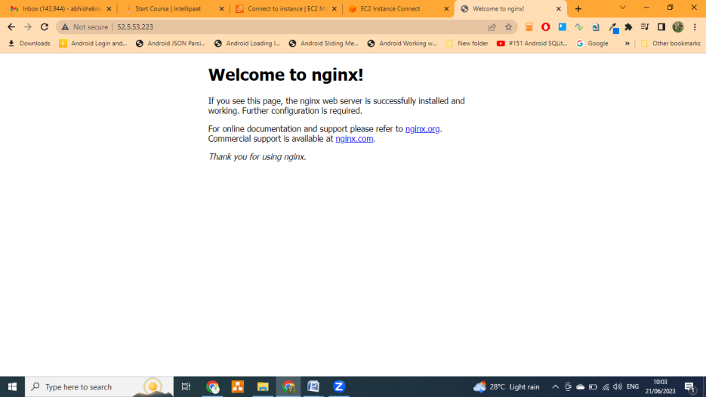

* 1. **Customize you Default message for type below command** 
     1. **ls**
     2. **cd /var/www/html**
     3. **sudo rm index.nginx-debian.html**
     4. **ls**
     5. **sudo nano index.html**

**<!DOCTYPE html>**

<html>

**<body>**

**<h1>Hello Word!!</h1>**

**<p>My first Ngnix Server is running with my ouw page.</p>**

**</body>**

**</html>**

* + 1. Write your own message or html page and save it by pressing **Ctrl + X and Y** or **Ctrl + S and Ctrl + X**
    2. Refresh your browser or type you public IP in browser and check

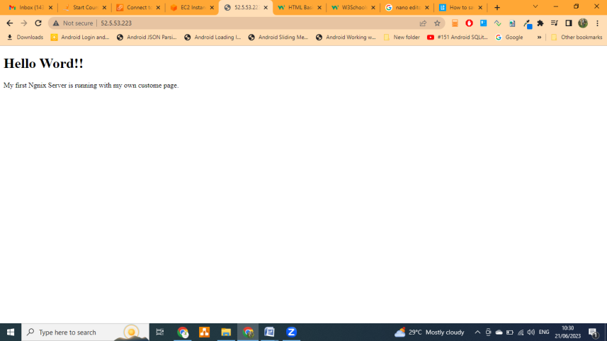

* + 1. Complete Command use

1. **clear** => To clear the terminal hsitory

2. **sudo apt update –y** => to update the VM

3. **sudo apt install nginx –y** => to install the nginx webserver

4. **history** => To show history

5. **clear** => clear the terminal

6. **ls** => to see the list file/folder in current directory

7. **cd /var/www/html** => nginx webserver application directory

8. **ls** => list of file/folder in current directory

9. **sudo rm index.nginx-debian.html** => delete the file

10. **ls**

11**. sudo nano index.html =>** create the file

**Workshop: 2 / Practice -2: Case study -2 | 20/06/2023**

**Problem:** You work for XYZ Corporation. Your corporation want to lunch web based application using AWS Virtual Machine. Configure the resources accordingly with appropriate storage for the task.

Task To be Performed

1. Lunch a Linux Ec2 instance
2. Create an EBS volume with 20GB of storage and attached it the created EC2 instance.
3. Resize the attaché volume and make sure it reflect in connected instance

**Lab: Practice**

1. Go To EC2 Dashboard
2. Create EC2 Instance
   1. Enter your “**Nmae & Tag**”
   2. Select the application OS : “**Ubuntu”**



* 1. Create or Select the “**Key Pair**”



* 1. Create or Select the “**Security Group**” and make sure you enable the All Trafic/HTTP “**Sourc & Port**” with “**0.0.0.0/0**”





* 1. Lunch the instance
  2. Instance Details Like below



* 1. Connect you EC2 Instance though Putty or aws CLI and run the below command
     1. **sudp apt update –y**
     2. **sudo apt install nginx –y**



* 1. Now time to open your or type your public IP in url and check. Surprises 😊 you will able to see welcome Msg on on page



* 1. Go To **EBS**(Elastic Block Storage)
     1. Tab on **volume**
     2. **Create Volume**

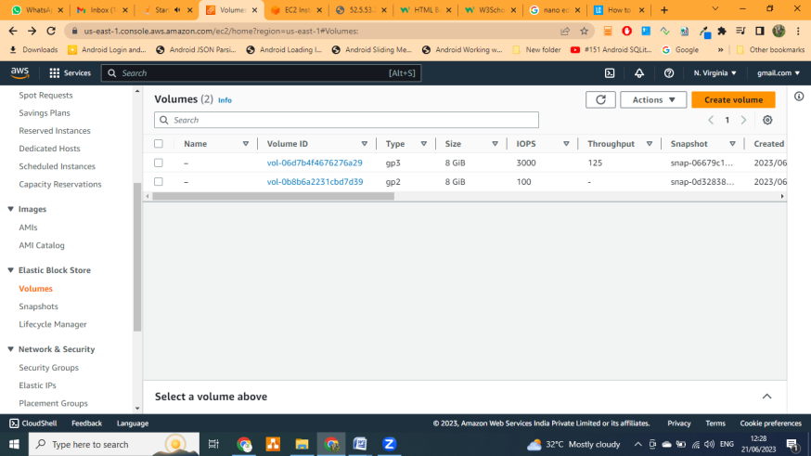

* + 1. Enter the volume details
       1. **Volume** Type => **Magnetic Standard**
       2. **Size** => **10GiB**
       3. **Availability Zone** => will be same as **your EC2 Instance AV only**

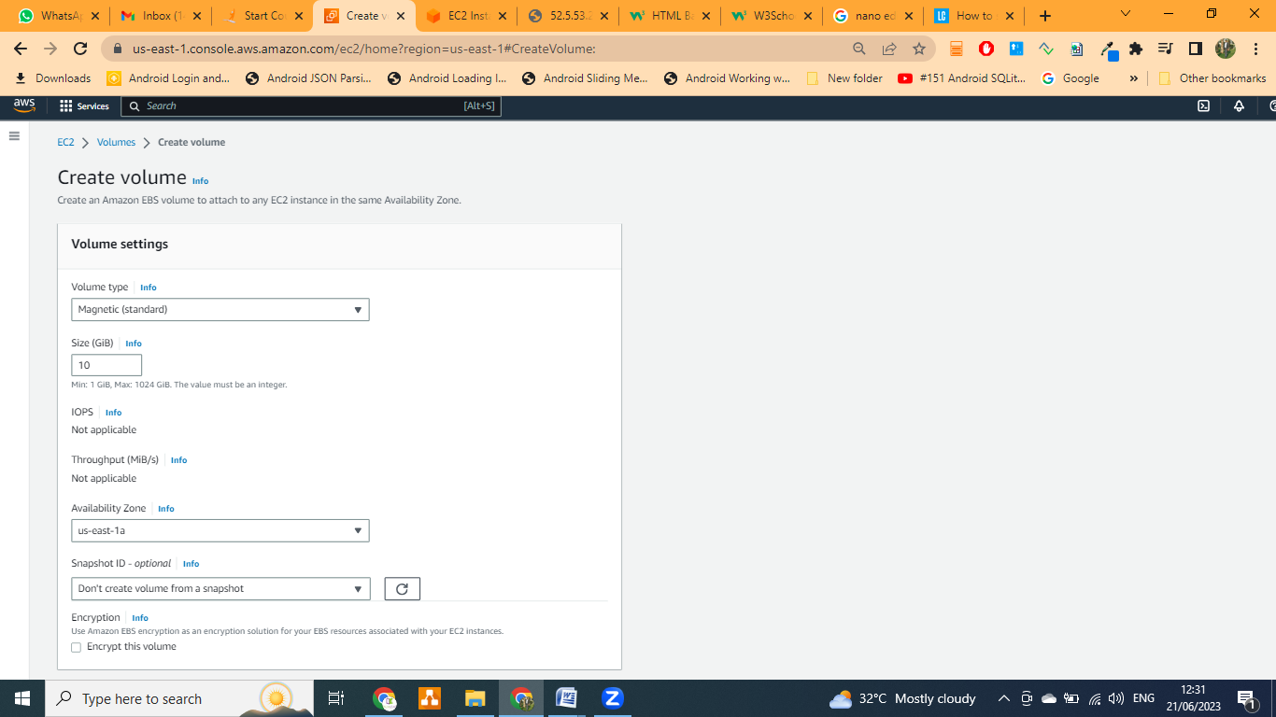

* + 1. **Create Volume**
    2. **Attach** the **volume**
       1. Select the **newly create volume**
       2. **Action**
       3. **Attach Volume**

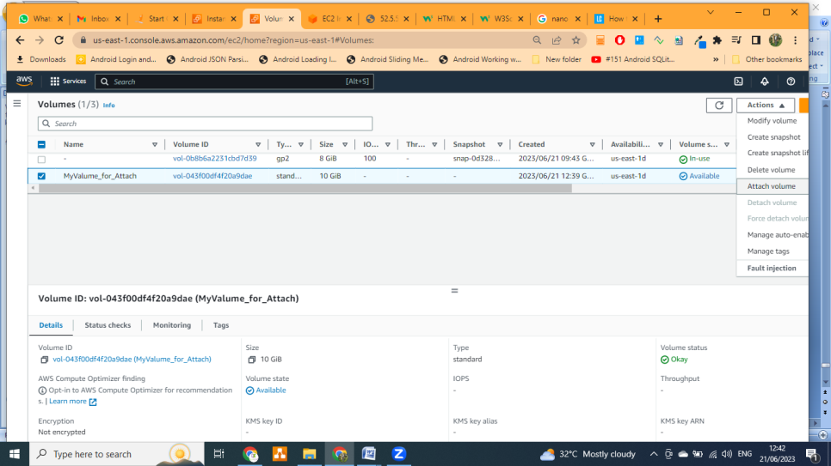

* + 1. **Select the Instance** in/on which you want to attach it and modify the device name if you want

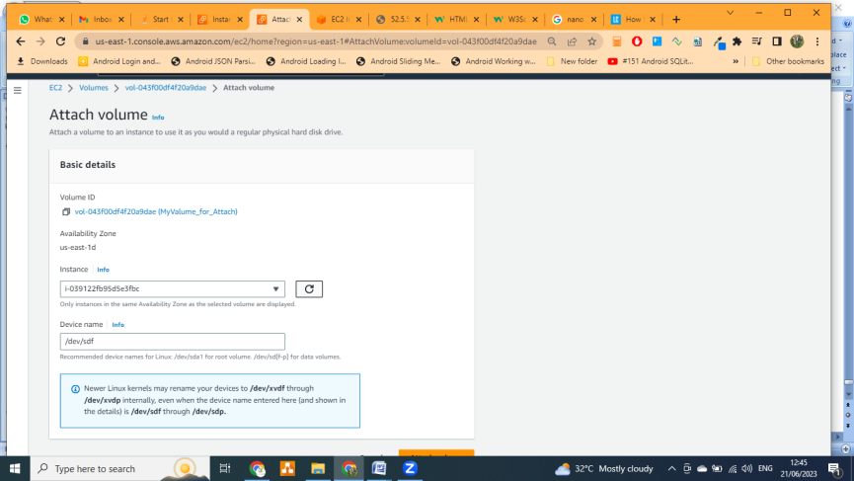

* + 1. Go to your instance and verify the volume
       1. Command : **lsblk**
       2. Or from **EC2 Dashbord**

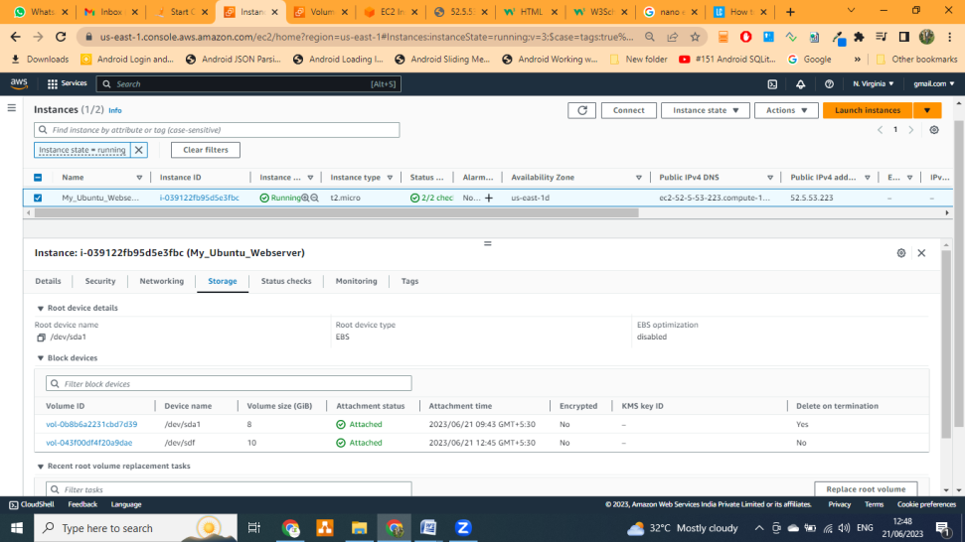

* + 1. **Resize** the **volume**:
       1. **Select** the **volume**
       2. **Action**
       3. **Modify Volume**
       4. Enter your **increases the volume size** (U Can only increase not decrease)

**Workshop: 3 / Practice -3: Case study -3 | 21/06/2023**

**Problem:** You work for XYZ Corporation. Your corporation working on application they require secured web server on Linux server to lunch an application.

Task to be performed

* + - 1. Create an instance in the US-East-1(N. Virginia) region with Linux OS(Amazon Linux) and manage the requirement of web server of your company using AMI.
      2. Replicate the instance in the US-West-2(Oregon) region.
      3. Build two EBS volumes and attach them to the instance in the US-East-1(N. Virgina) region.
      4. Delete one volume after detaching it and extend the size other volume.
      5. Take backup of this EBS volume

**Lab: Practice**

1. Go To EC2 Dashboard
2. Create EC2 Instance
   1. Enter your “**Nmae & Tag**”
   2. Select the application Linux base OS : “**Amazon Linux”**
   3. Select your AMI => “**Amazon Linux 2023 AMI….**”
   4. Select the Architecture => **64-bit(x86)**
   5. Select the Instance Type: **t2.micro**

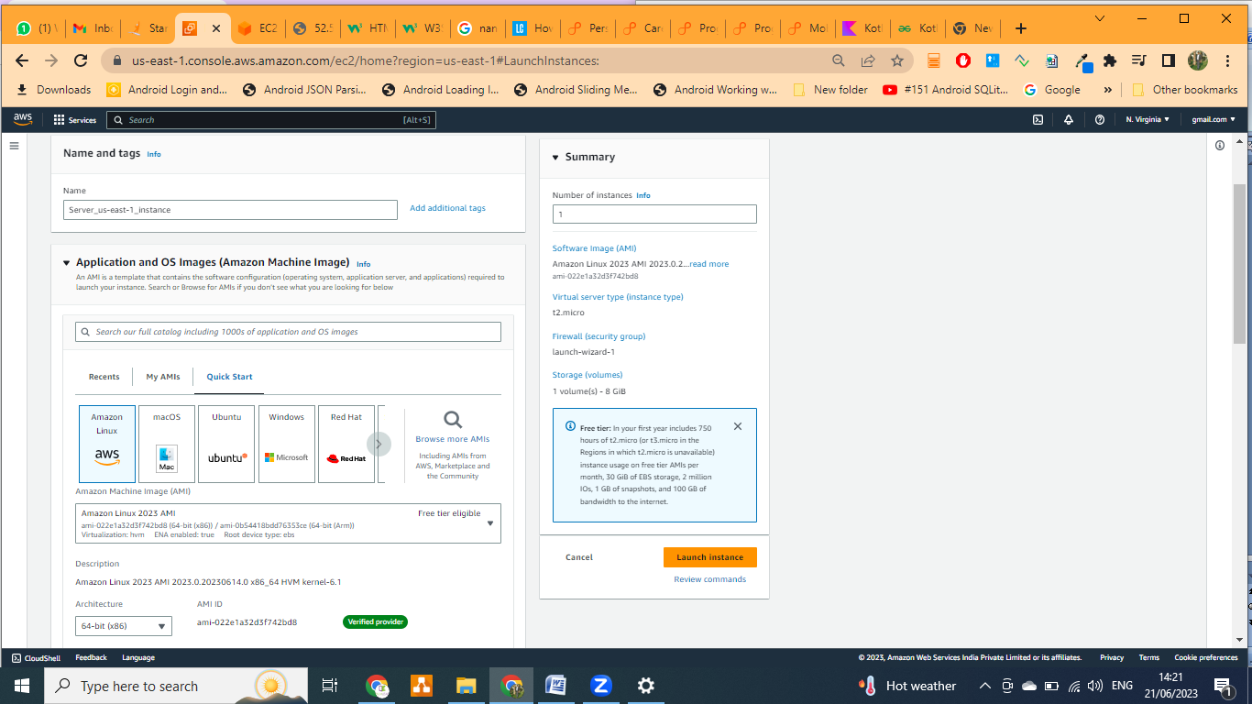

* 1. Select or create your Key-Pair(For login)
  2. Network Setting
     1. Select or create **Firewall(security Group)**
     2. Make sure you allowed all possible traffic, port to access the server(**Allow SSH traffic from & Allow HTTP traffic from internet or AllTracffic** with **0.0.0.0/0**)

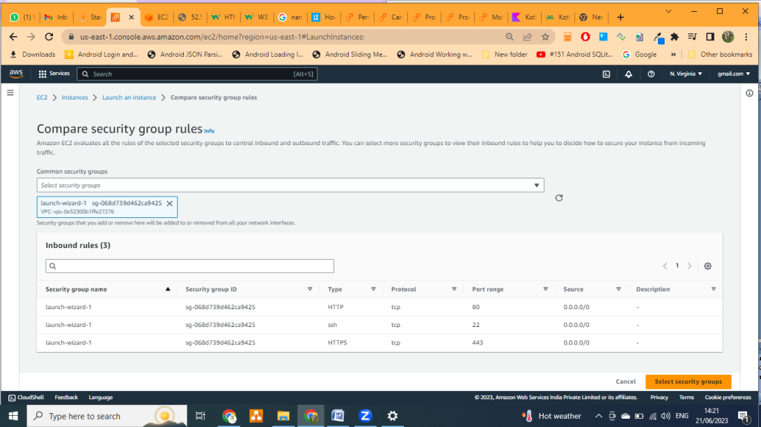

* + 1. **Lunch** the **Instance**
  1. **Go to EC2 Dashboard**

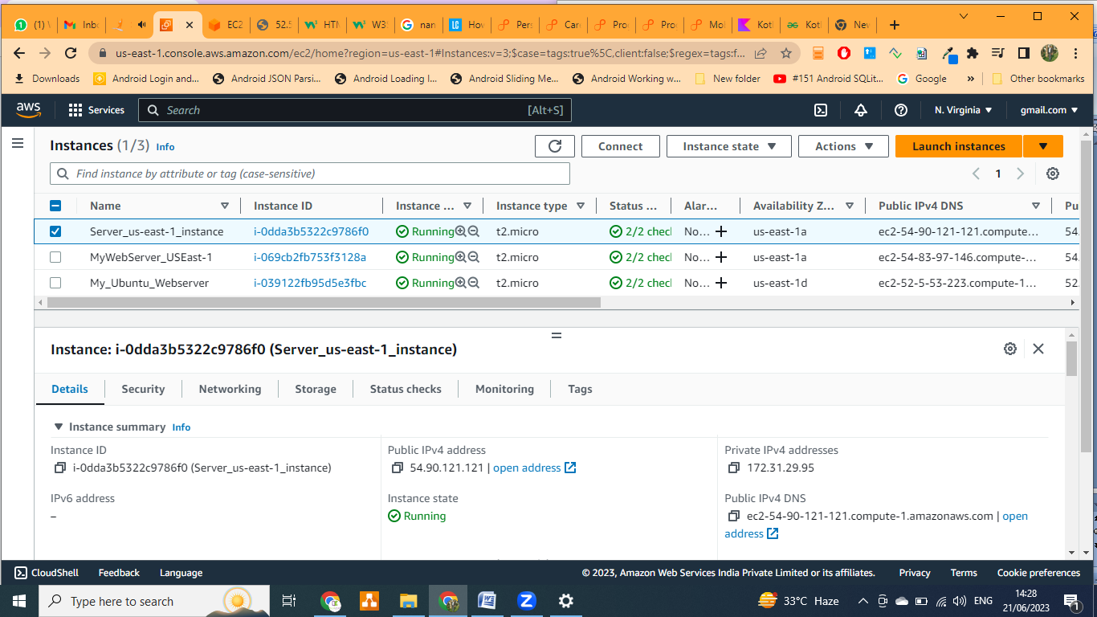

* 1. **Connect your EC2 instance through AWS CLI or Putty**

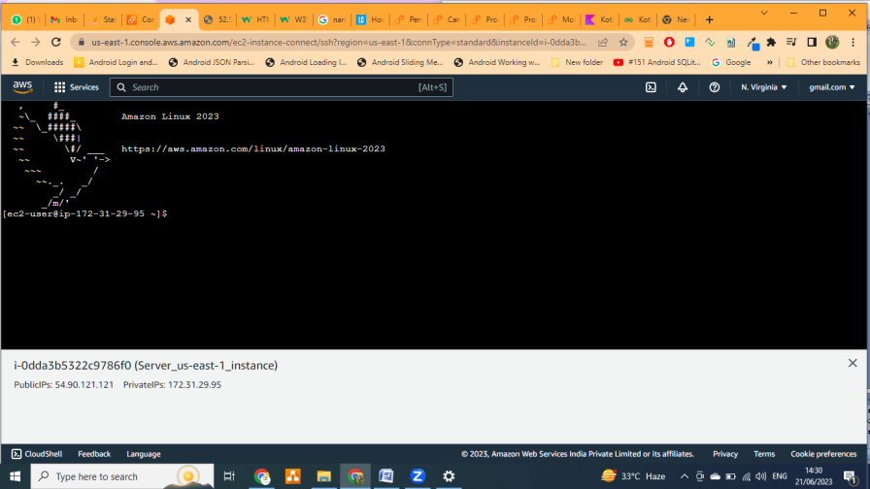

* 1. **Then performed the below command**

1  **sudo yum update -y**

2 **sudo yum install httpd**

3 **sudo systemctl enable httpd**

4 **sudo systemctl start httpd**

5 **clear**

6 **history**

* 1. **Open** you **browser** and type your **Public IP** in **URL**

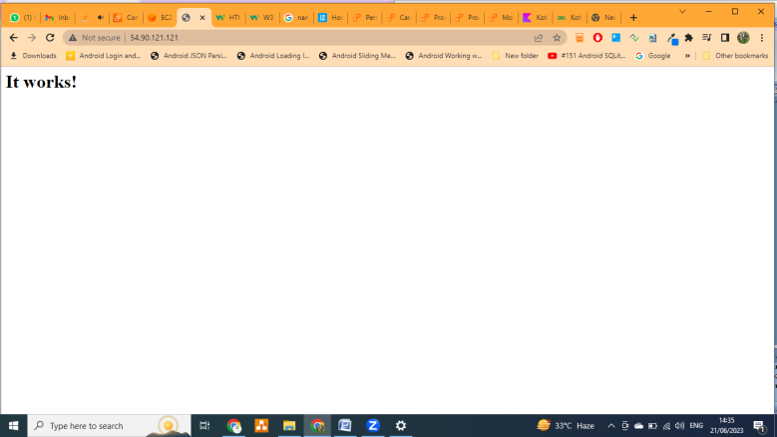

* 1. **Create the Instance Image(AMI)**

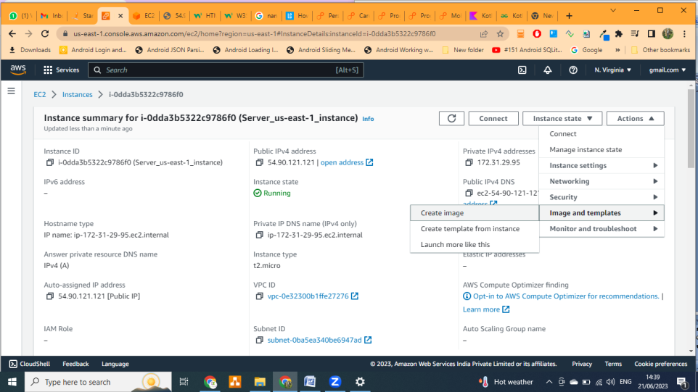

* 1. **Create a Backup Image**

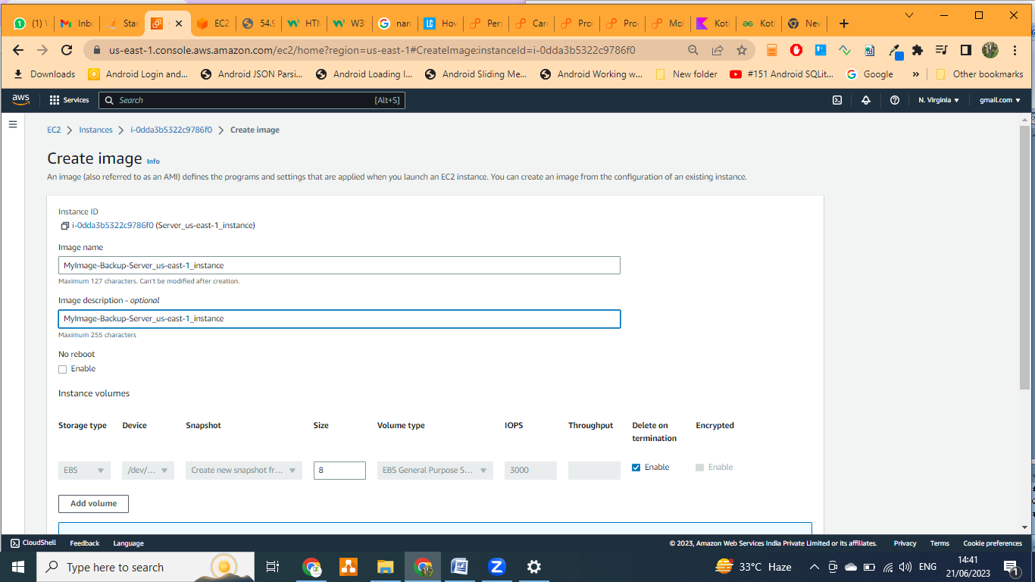

* 1. **Go to Image => AMIs**

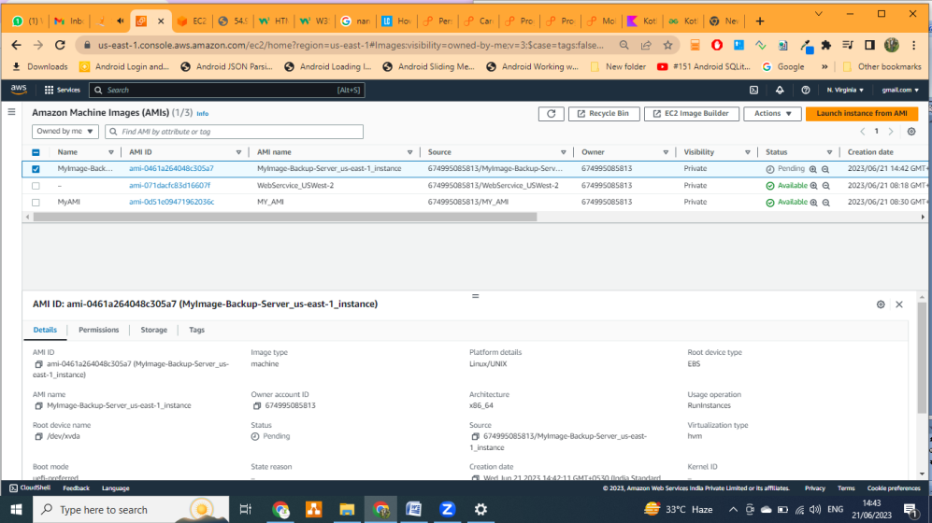

* 1. **Create Volume** 
     1. **Go To Volume**
     2. **Create Volume**

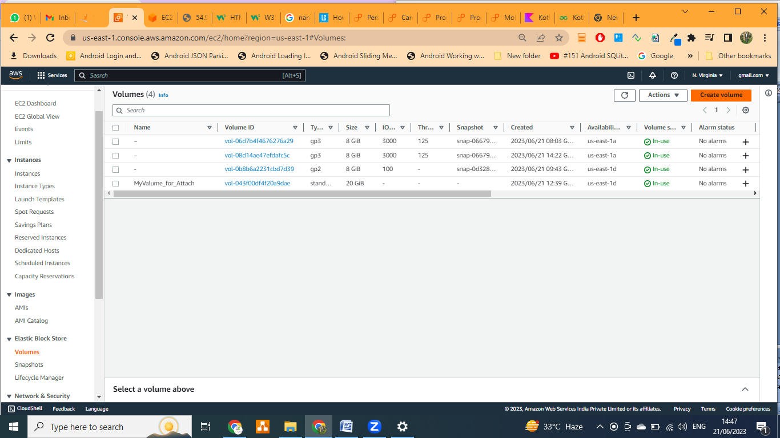

* + - 1. **Select Volume Type:** General Purpose SSD
      2. **Size: 20Gib**
      3. **Availability Zone: will be same as EC2 Instance AV Zone**
  1. **Go to EBS => Volume**
     1. **Select the** Volume which you want to attach
     2. **Action**
        1. **Attach**

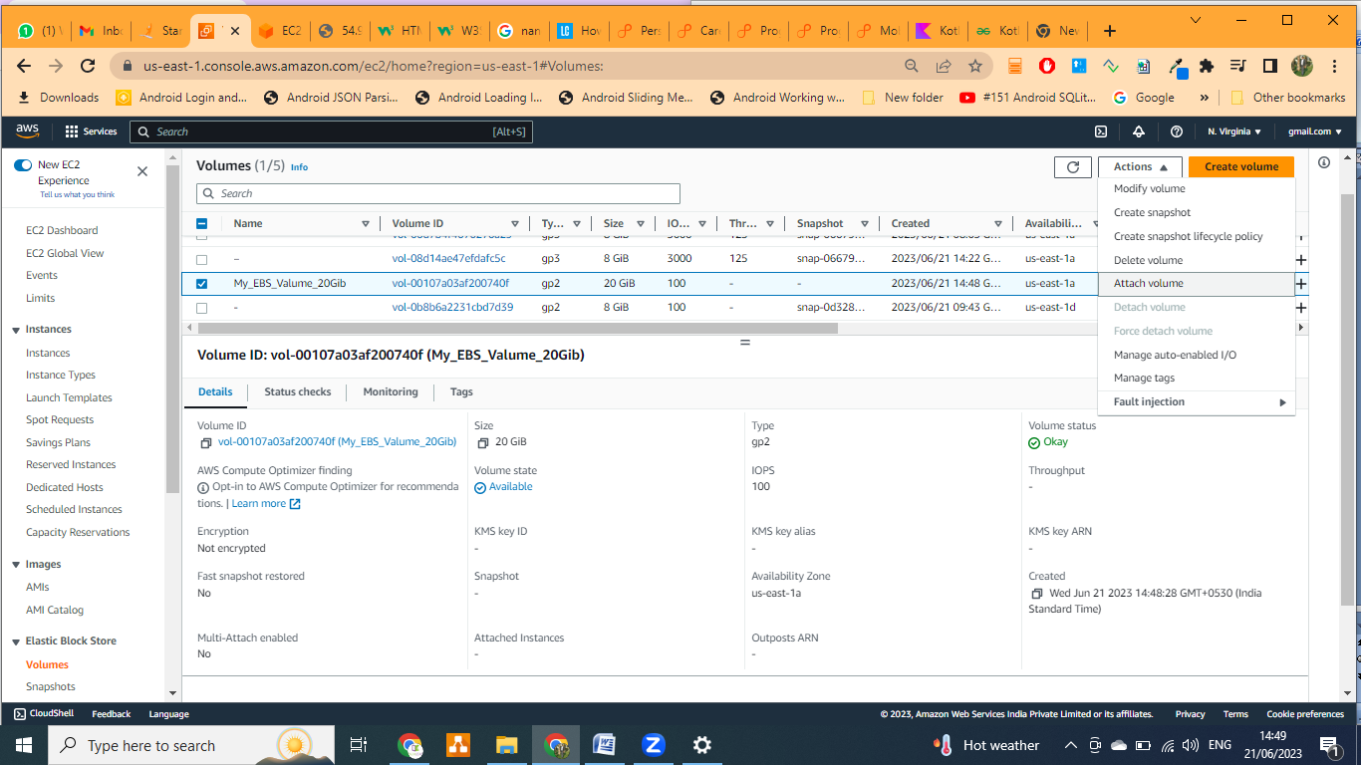

* + 1. **Select the instance**

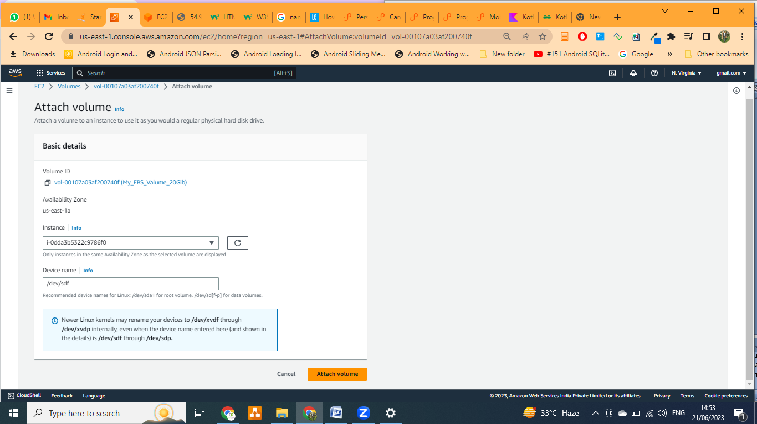

* + 1. **Attach Volume**
  1. **Create one more EBS** with same step but **Size will be 30GiB and Attach them with Ec2 Instance**
  2. **Go To EC2 check your volume storage** 
     1. Putty**: lsblk**

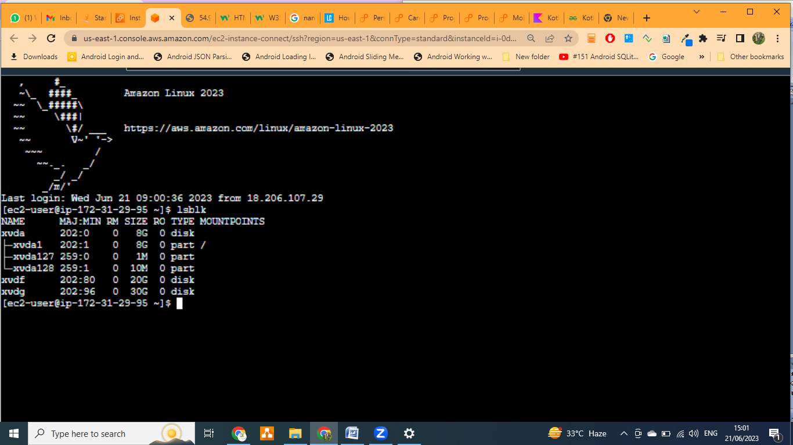

* + 1. Select Instance**: Storage**

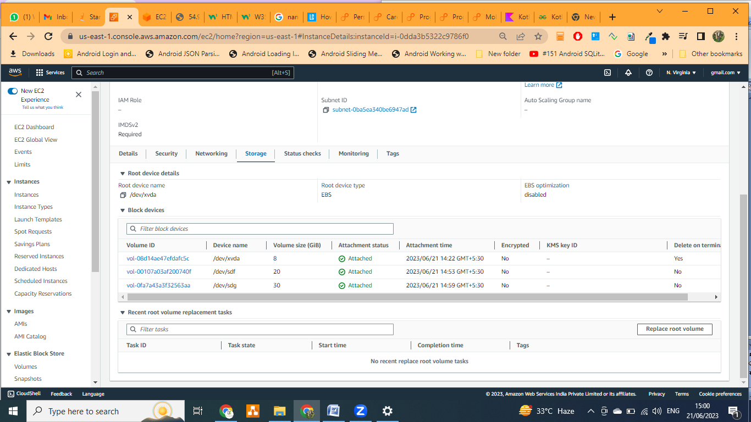

* 1. **Detach and Delete the volume** 
     1. **Detach the volume**
        1. **Go To volume**
        2. **Select the Volume**
        3. **Action**
        4. **Detach**

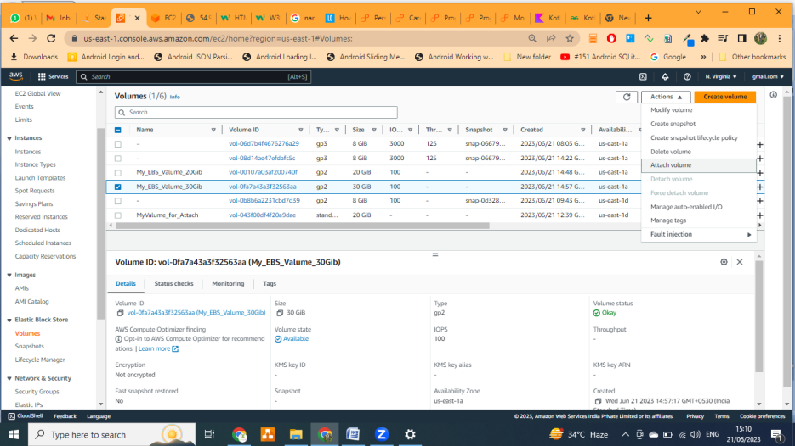

* + 1. **Delete the Volume**
       1. **Go To volume**
       2. **Select the volume**
       3. **Delete**

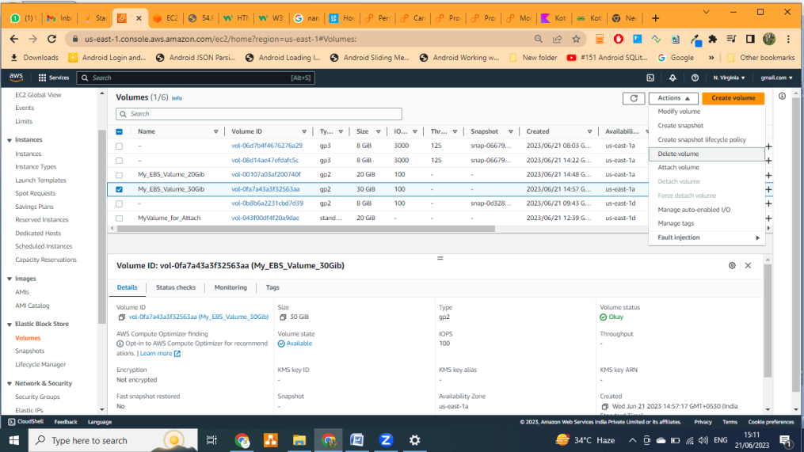

**New Volume Details**

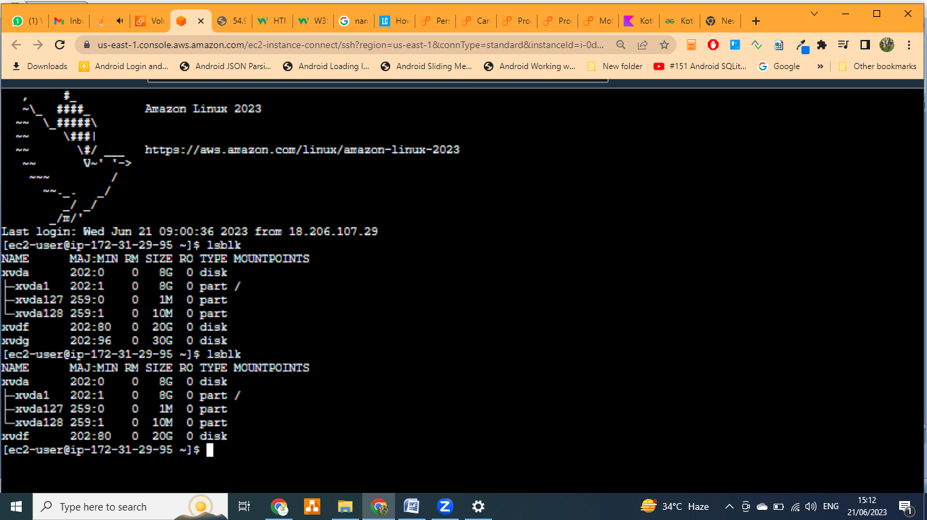

* 1. **Copy The EC2 AMIs / Backup / Image into different Region from AMIs (Create the Instance from backup AMIs)**
     1. **Go To Image**
     2. **AMIs**
     3. **Select your AMI**
     4. **Action**
     5. **Copy AMI**

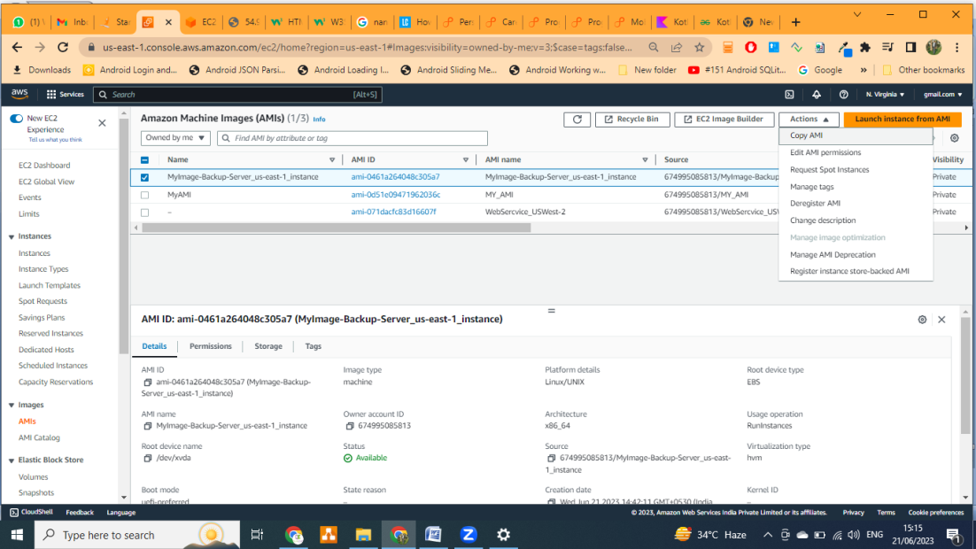

* + 1. Change the Destination Region like (US West – oregon **=> u-west-2)**

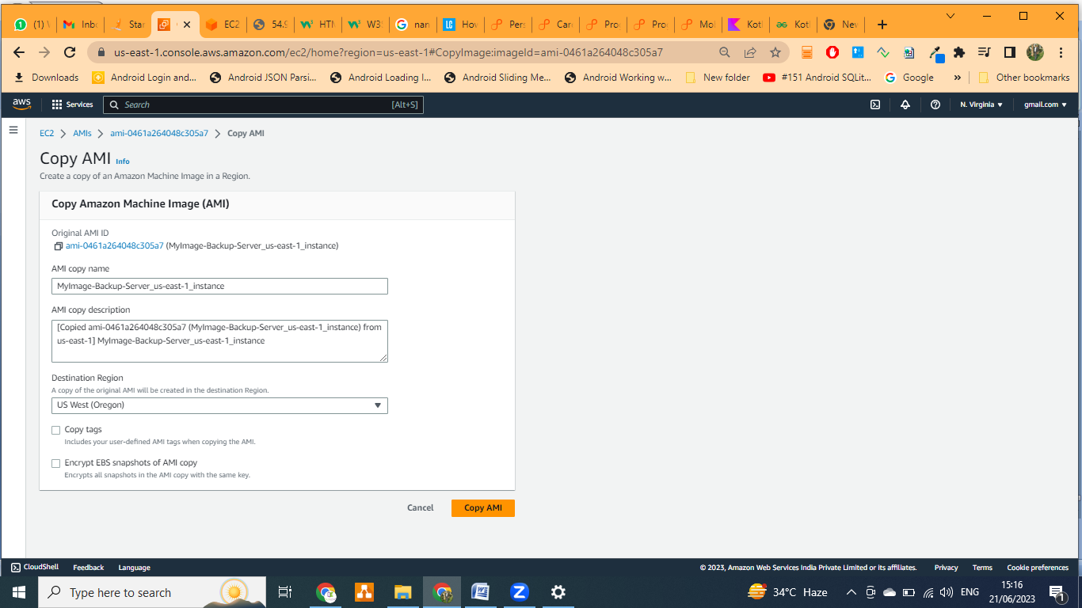

* + 1. Click on **Copy AMI**
    2. **Change your Region**

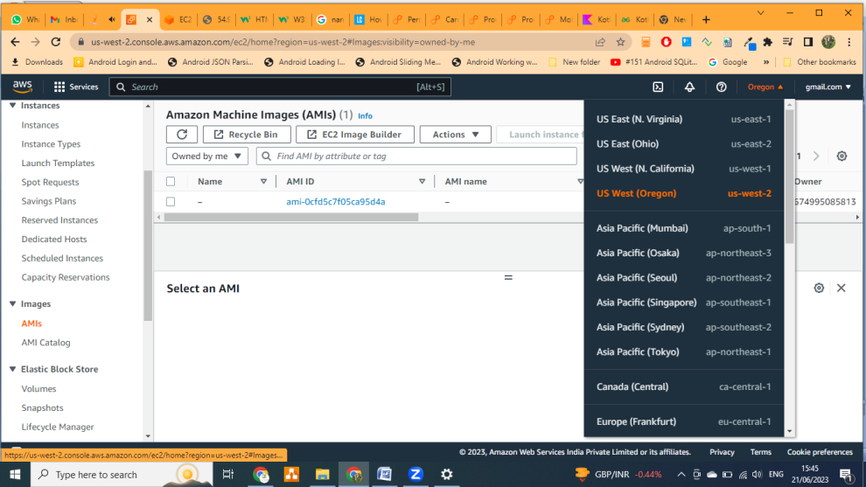

* + 1. **Image**
       1. **AMIs**

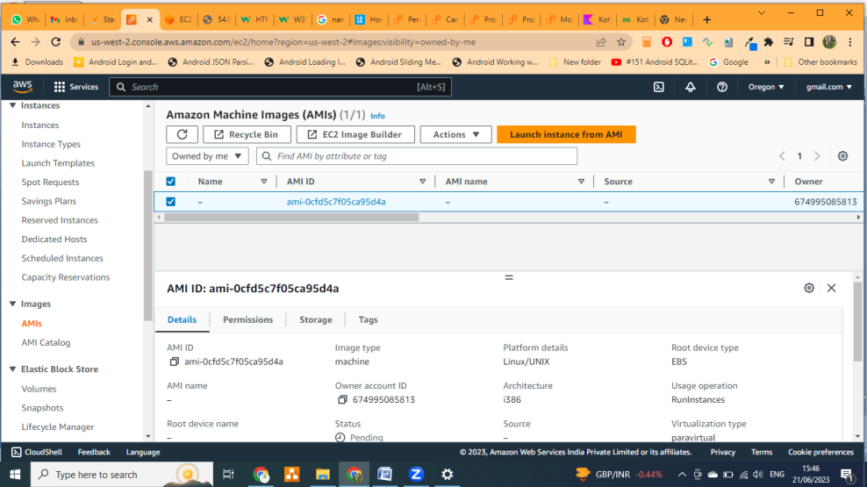

* + - 1. **Lunch the Instance** 
         1. **Image => AMIs => Select the image**

**Lunch the instance from our AMIS**

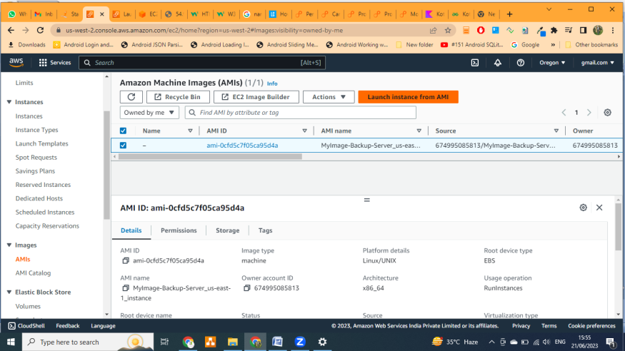

* + - * 1. Lunch the image from EC2 instance

Go to **EC2 DashBoard**

Enter your name

Tab on **My AMIs**

Select the  **AMIs**

Create the Instance by selecting **Key-Pair and Securities group**

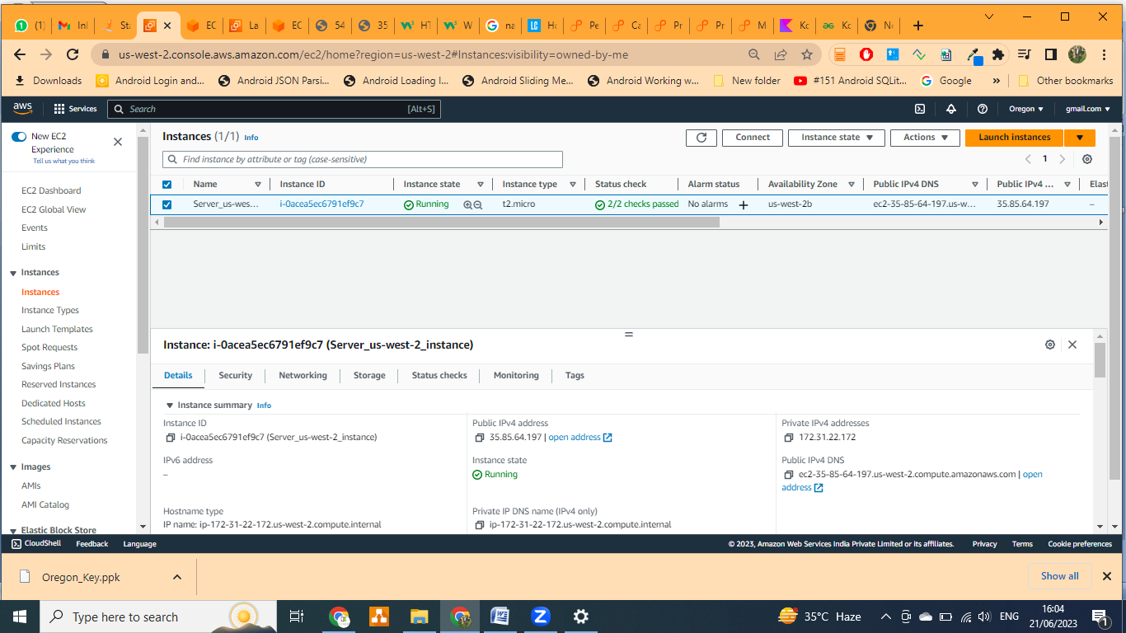

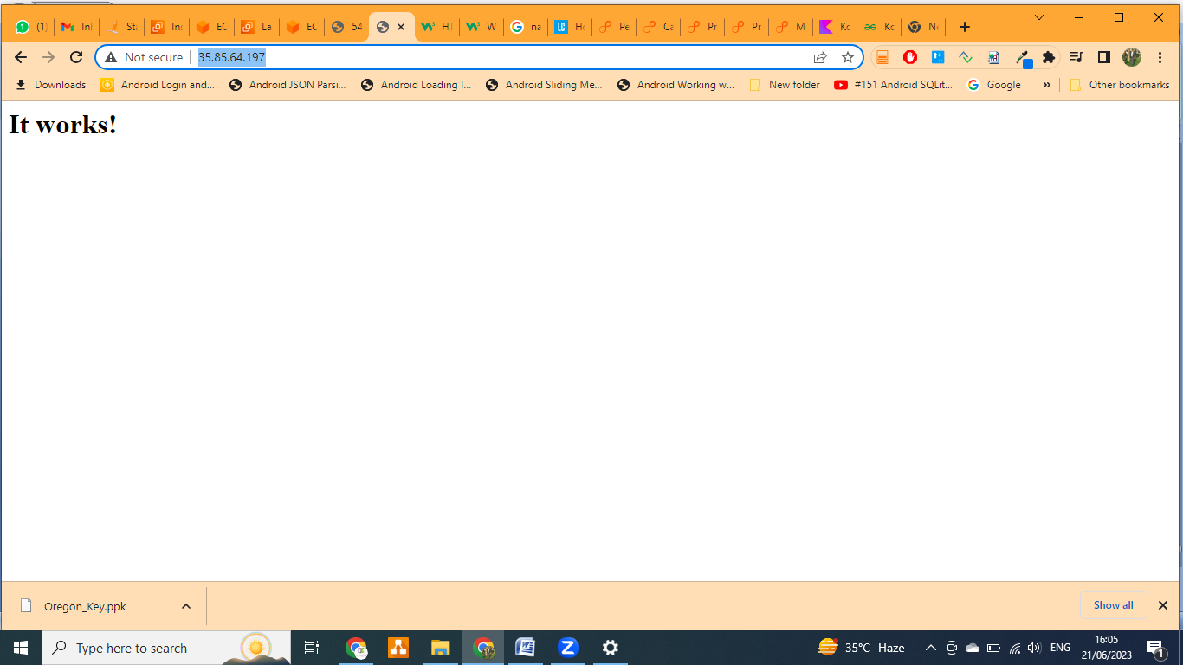

So web Application is working from both region with down time & without any latency with high availability